E-Library Management System

**Overview:**

**Use Case Diagram**

User (Student)……………………………………………………………………page 2.

Admin (Teacher)………………………………………………………………...page 3.

**Class Diagram**……………………………………………………..………………………page 4.

**Sequence Diagrams**

User (Student)……………………………………………………………………page 5.

Admin (Teacher)………………………………………………………………...page 6.

**State Chart Diagrams**

User (Student)……………………………………………………………………page 7.

Admin (Teacher)………………………………………………………………...page 8.

**Activity Diagrams**

User (Student)……………………………………………………………………page 9.

Admin (Teacher)………………………………………………………………...page 10.

**Deployment Diagram**

Introduction……………………………………………………………………..………page 11.

Diagram Explanation……………………………………………………………………page 13.

**Use Case Diagram**

1. **User (Student)**

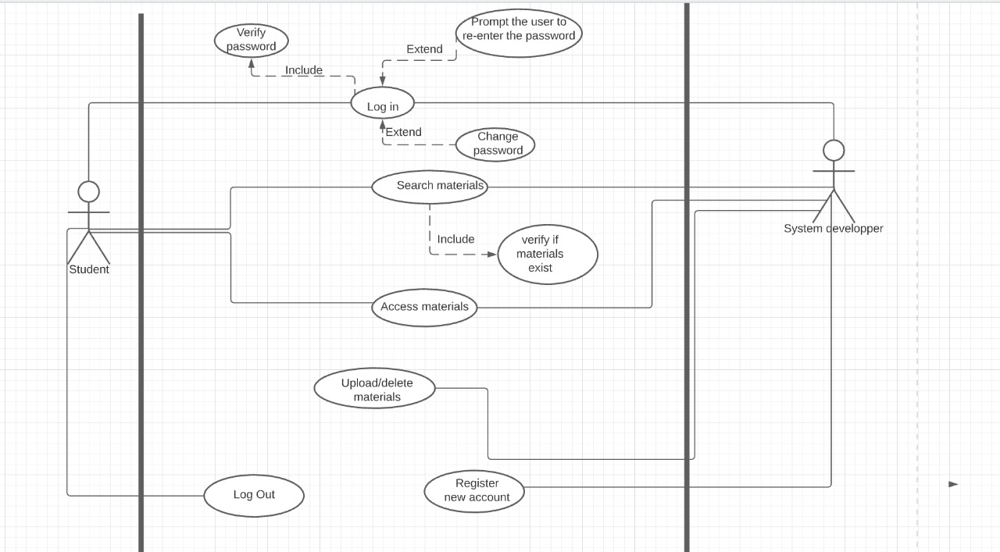

**Use Case Diagram**

1. **Admin (Teacher)**

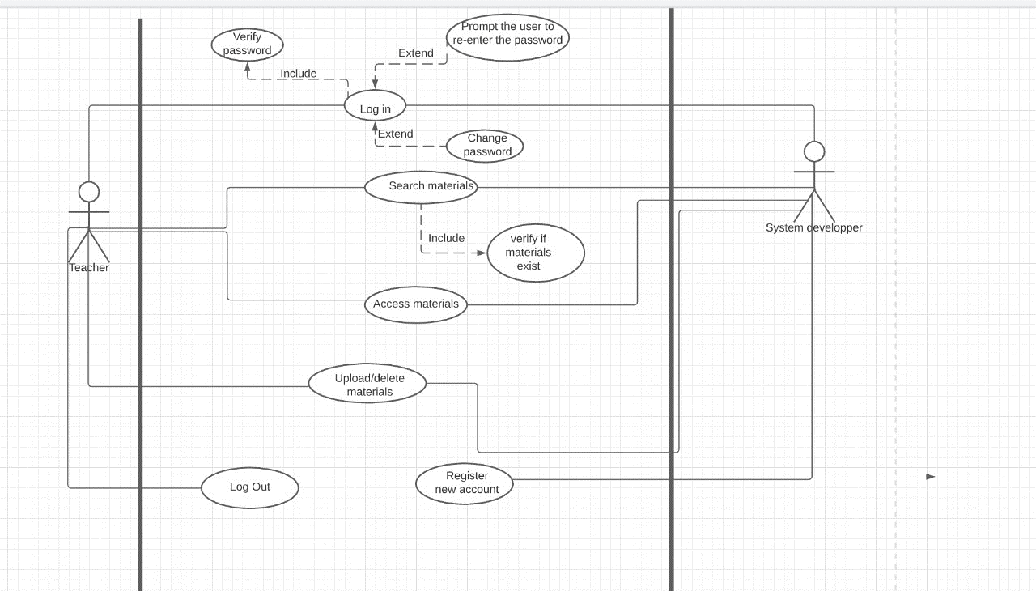

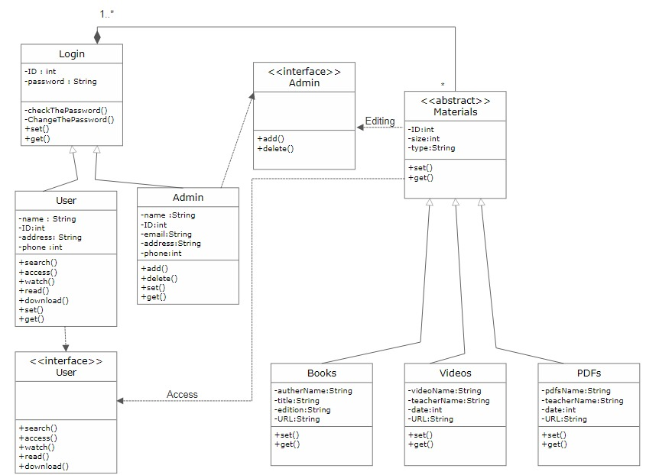**Class Diagram**

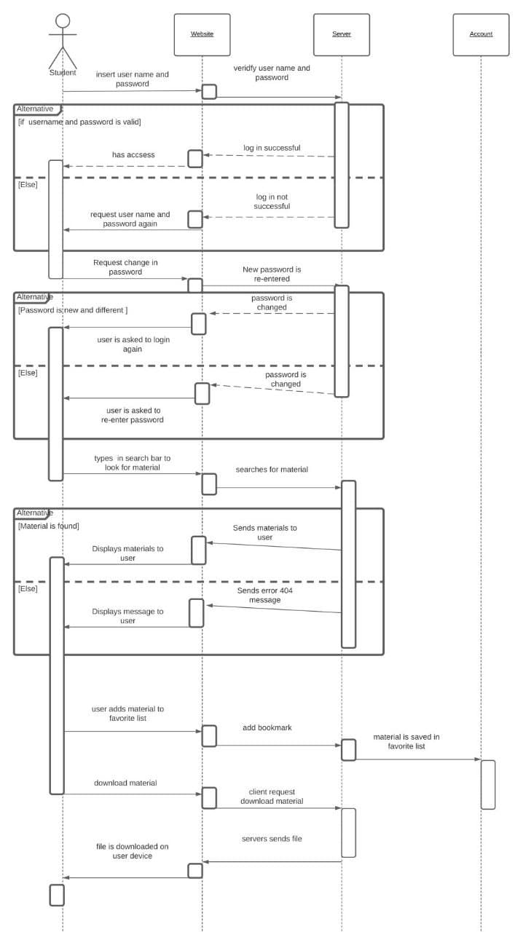**Sequence Diagrams**

1. **User (Student)**

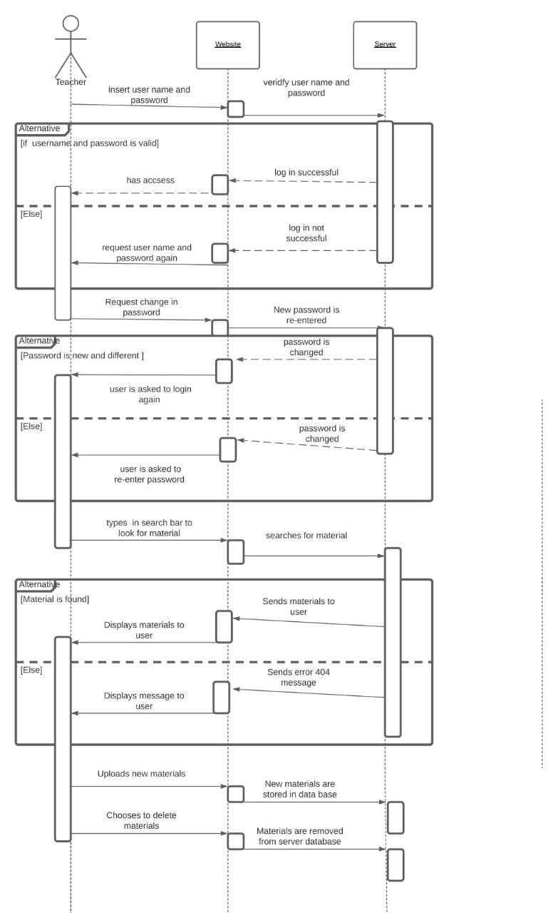**Sequence Diagrams**

1. **Admin (Teacher)**

**State Chart Diagrams**

1. 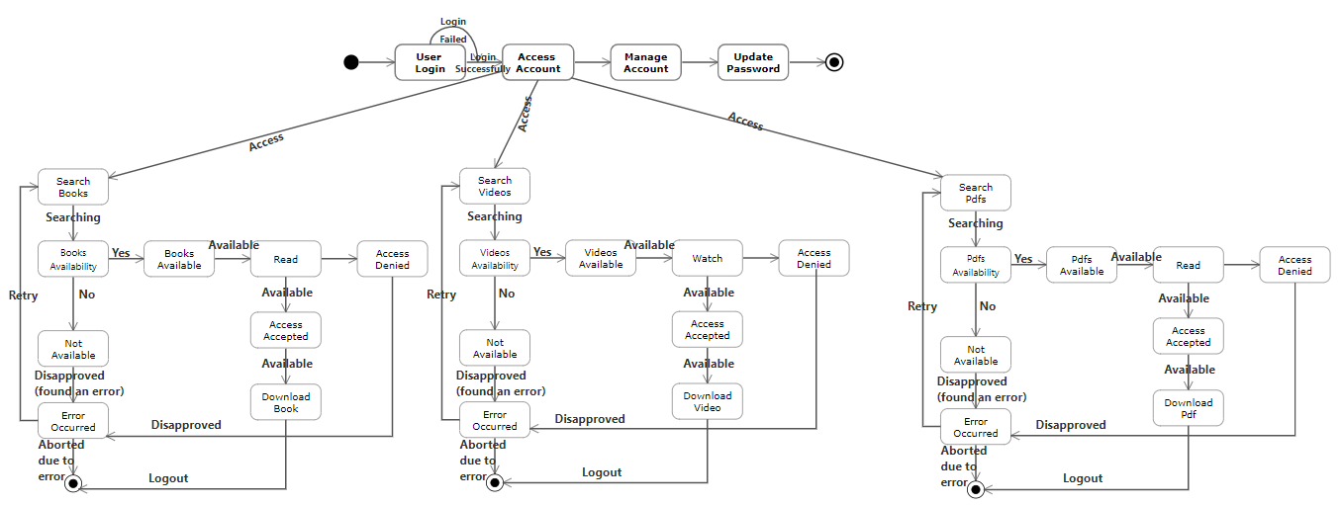**User (Student)**

**State Chart Diagrams**

1. 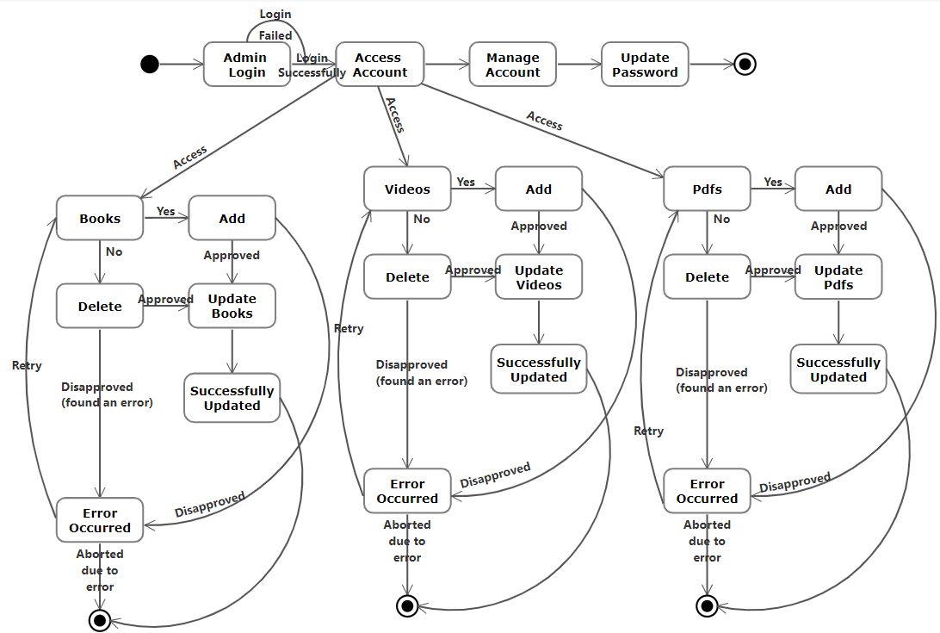**Admin (Teacher)**

**Activity Diagram**

1. 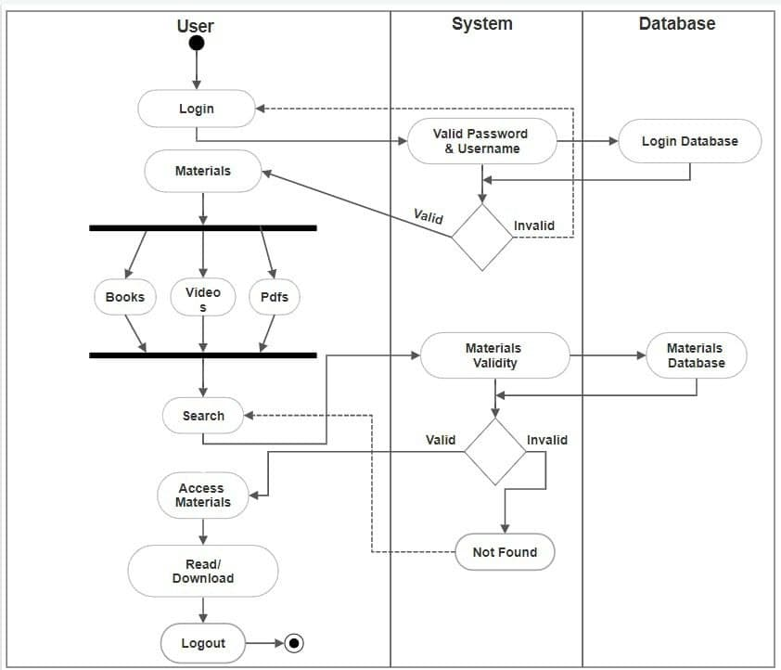**User (Student)**

**Activity Diagram**

1. **Admin (Teacher)**

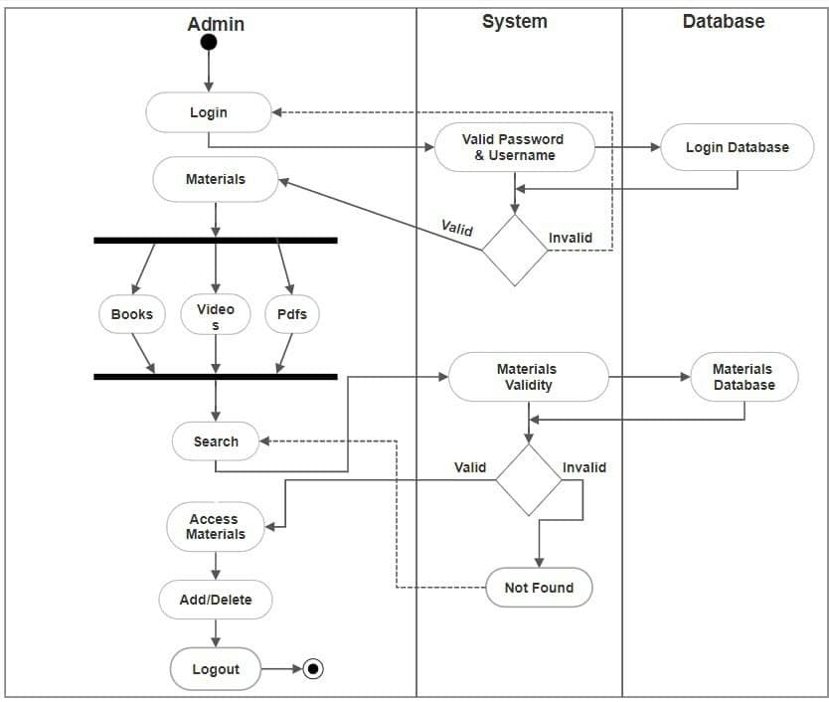

**Deployment Diagram**

1. **Explanation:**

A UML deployment diagram is a diagram that shows the configuration of run time processing nodes and the components that live on them. Deployment diagrams is a kind of structure diagram used in modeling the physical aspects of an object-oriented system. The deployment diagram maps the software architecture created in design to the physical system architecture that executes it.

**Deployment Diagram elements**

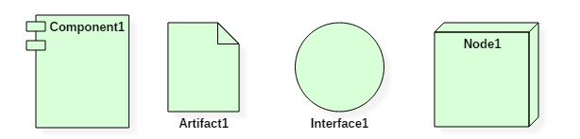

* **Artifact:**A product developed by the software.
* **Association:** A line that indicates a message or other type of communication between nodes.
* **Component:**A rectangle with two tabs that indicates a software element.
* **Dependency:**A dashed line that ends in an arrow.
* **Interface:**A circle that indicates a contractual relationship.
* **Node:**A hardware object which is used to deploy the software, shown by a 3D box.
* **Node as container:**A node that contains another node inside of it.
* **Package:** A file-shaped box that groups together all the device nodes to encapsulate the entire deployment.

**A deployment diagram plays a critical role during the administrative process:**

* High performance
* Maintainability
* Scalability
* Portability
* Easily understandable

1. **Deployment Diagram:**

